**E-Commerce Shopping Application Project Documentation**

1. **Project Overview**
2. **Features Implemented**
3. **Technology Stack**
4. **Implementation Steps**
5. **Pages Developed**
6. **Future Enhancements**
7. **Project Overview**

The E-Commerce Shopping Application is a web-based platform developed using modern web technologies. It enables users to browse products, add items to their Wishlist or cart, and proceed to checkout. An Admin Panel is provided for managing products**.**

* 1. **Technologies Used**

|  |  |
| --- | --- |
| **Component** | **Technologies Used** |
| **Frontend** | Angular, HTML, CSS, Bootstrap, java Script |
| **Backend** | Spring Boot, MySQL, Spring Security, JWT Token |
| **Tools** | VS Code, Eclipse, MySQL Workbench |
| **Version Control** | Git & GitHub |

* 1. **System Architecture**

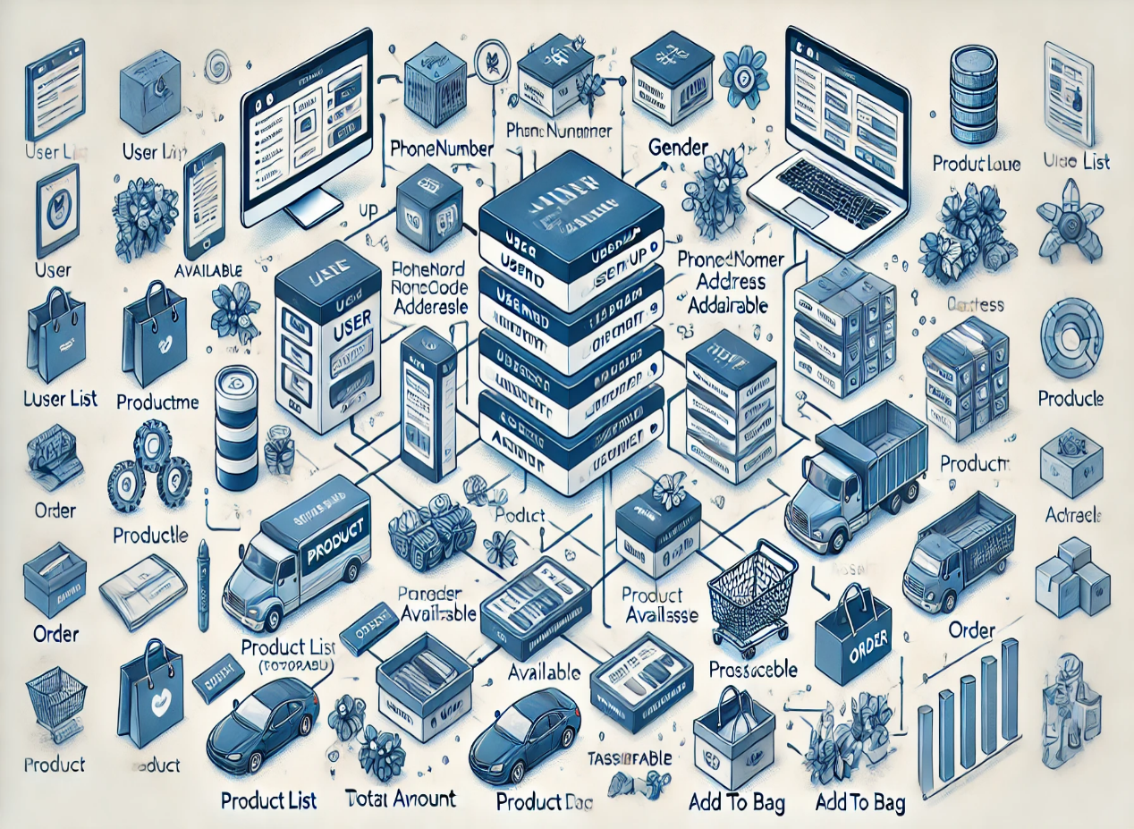

1. **Features Implemented**

**2.1 User Authentication & Authorization**

* Secure login and signup using JWT token-based authentication.
* Spring Security ensures user role management (Admin & Customer).

**2.2 Product Filtering & Searching**

* Users can filter products by Gender, Brand, Colour, Price, and Product Type.
* A search bar allows quick access to desired products.

**2.3 Wishlist & Add to Bag**

* Users can save products for later.
* Easily add products to the shopping cart.

**2.4 Checkout Process**

* Users can proceed to checkout and place orders (Payment integration not included).

**2.5 Admin Panel**

* Admin can add, update, and delete products.

**2.6 Email Notifications**

* Users receive an email confirmation upon successful order placement.

1. **Technology Stack**

|  |  |
| --- | --- |
| **Layer** | **Technology** |
| **Frontend** | Angular, TypeScript, HTML, CSS, Bootstrap |
| **Backend** | Spring Boot, Spring Security, JWT Authentication |
| **Database** | MySQL (via MySQL Workbench) |
| **Email Service** | Java Mail Sender for notifications |

1. **Implementation Steps**

**4.1 Frontend Development (Angular)**

1. Set up an Angular project using Angular CLI.
2. Design UI using HTML, CSS, and Bootstrap.
3. Implement routing for seamless navigation.
4. Use Angular Services to communicate with the backend.
5. Implement JWT authentication for secure user sessions.

**4.2 Backend Development (Spring Boot)**

1. Create a Spring Boot project with dependencies like Spring Security, JWT, MySQL, and JavaMailSender.
2. Develop REST APIs for authentication, product management, cart, and checkout.
3. Implement user roles (Admin & Customer) using Spring Security.
4. Integrate MySQL for data storage.
5. Configure JavaMailSender for email notifications.

*(Insert an ER Diagram here showing the database schema.)*

**5. Pages Developed**

|  |  |
| --- | --- |
| **Page Name** | **Description** |
| **Logo Page** | Displays the application logo on launch. |
| **Signup Page** | Allows new users to register. |
| **Login Page** | Authenticates users before accessing the application. |
| **Home Page** | Displays product listings with filtering options. |
| **Wishlist** | Stores saved products for later purchase. |

|  |  |
| --- | --- |
| **Add to Bag** | Shows items added to the shopping cart. |
| **Checkout Page** | Displays order summary before placing an order. |
| **Product Details Page** | Displays detailed information about a product. |
| **Place Order Page** | Confirms order placement. |
| **Admin Page** | Allows admins to manage products. |
| **Add Product Page** | Admin interface for adding new products. |

**6. Project Limitations**

1. **No Payment Gateway** - Currently, payments are not integrated.
2. **Not Hosted Yet** - The application runs locally and is not yet deployed.

**7. Future Enhancements**

* **Payment Gateway Integration** (e.g., PayPal, Stripe).
* **User Review & Ratings System** for products.
* **Product Recommendation Engine** using AI.
* **Order Tracking System** with shipment updates.

**Contact details:**

**Phone: 9989896541**

**LinkedIn Id:** [**www.linkedin.com/in/jogeswara-rao-urumu-355b21252**](http://www.linkedin.com/in/jogeswara-rao-urumu-355b21252)

**Prepared By:** Jogeswara Rao Urumu